**MeAcqManager (Acq)**

MeAcqManager (Acq) is one of the most powerful, precise and comprehensive software available for recording and monitoring magnetic and electrical signals.

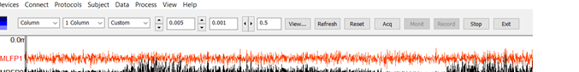

**A Complete Solution for Recording High Spatiotemporal Signals**

* *Support the data acquisition of magnetic signal, electrical signal, trigger signals and much more*
* *Extensive functions for wireless and wired recordings from multi-channel system*
* *Build-in motion monitoring function for wearable devices, free from complicated wires and limited space*
* *Direct link to well defined paradigms for the study of brain functions (e.g., from motor to language)*
* *Advanced online filtering for real-time noise cancellation*
* *Accurate localization of sensor position, orientation and more*
* *Direct access computer hardware for critical functionalities, productivity and efficiency*
* *Advance functions for remote recordings and monitoring with Direct-WiFi*
* *Intriguing and intelligence data acquisition setup for both clinical and research work.*